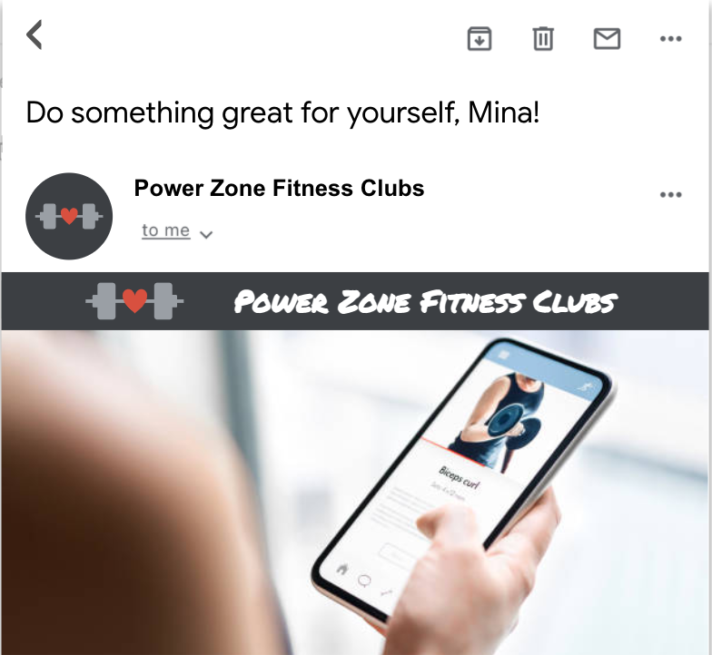

Professional fitness on the go



| Hi {{ fname }}!  We know that going to the gym is hard when you need to be next to your loved ones to take care of them.This is why we created the Power Zone app, so you can stay fit anywhere. The app provides online classes, and virtual personal training with our professional fitness coaches. It can also help you track your fitness progress, and help you get a customized workout routine so you get to your desired fitness goal. You need to take care of your health so you can keep taking care of them.   | Download the App Now | | --- |   With respect and gratitude,  Power Zone |
| --- | --- |